Segment

🧱 What Is a Segment in Network Data Structures?
# Source: Chatgpt (GPT‑5 Mini) at [12/14/2025]
A segment is a unit of data at the Transport Layer (Layer 4) of the OSI or TCP/IP model, created by TCP. It includes a TCP header and a payload (typically data from the Application Layer).

🧠 Simple Definition:
# Source: Chatgpt (GPT‑5 Mini) at [12/14/2025]
A segment is a chunk of data generated by the TCP protocol at the Transport Layer, carrying both control information (in the header) and user data (payload).

📚 Where Segment Fits in the OSI Model:
# Source: Chatgpt (GPT‑5 Mini) at [12/14/2025]
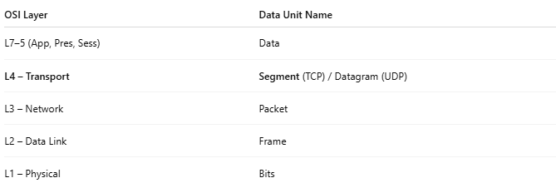
OSI Layer | Data Unit Name
L7–5 (App, Pres, Sess) | Data
L4 – Transport | Segment (TCP) / Datagram (UDP)
L3 – Network | Packet
L2 – Data Link | Frame
L1 – Physical | Bits

🧩 Structure of a TCP Segment:
# Source: Chatgpt (GPT‑5 Mini) at [12/14/2025]
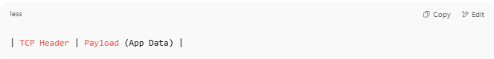
| TCP Header | Payload (App Data) |

🧾 Example: TCP Segment Fields
# Source: Chatgpt (GPT‑5 Mini) at [12/14/2025]
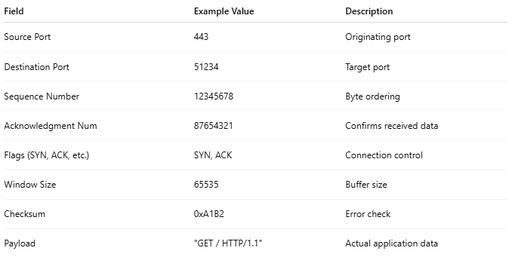
Field | Example Value | Description
Source Port | 443 | Originating port
Destination Port | 51234 | Target port
Sequence Number | 12345678 | Byte ordering
Acknowledgment Num | 87654321 | Confirms received data
Flags (SYN, ACK, etc.) | SYN, ACK | Connection control
Window Size | 65535 | Buffer size
Checksum | 0xA1B2 | Error check
Payload | "GET / HTTP/1.1" | Actual application data

🧠 Example Flow:
# Source: Chatgpt (GPT‑5 Mini) at [12/14/2025]
- You send a message (e.g., an email).
- That message becomes application-layer data.
- The TCP protocol breaks it into segments, adds headers, and passes them to the IP layer.
- The IP layer wraps each segment into a packet.

🧱 Segment – Visual Example
# Source: Chatgpt (GPT‑5 Mini) at [12/14/2025]
Absolutely! Here’s a 🧱 Visual Example of a TCP Segment, showing its structure, where the header ends, and where the payload begins.

🧾 TCP Segment – Visual Structure
# Source: Chatgpt (GPT‑5 Mini) at [12/14/2025]
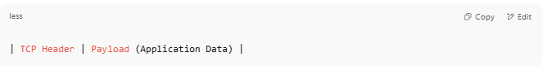
| TCP Header | Payload (Application Data) |

🧱 Example: TCP Segment with HTTP Payload

🧩 TCP Segment Fields (20 bytes standard)
# Source: Chatgpt (GPT‑5 Mini) at [12/14/2025]
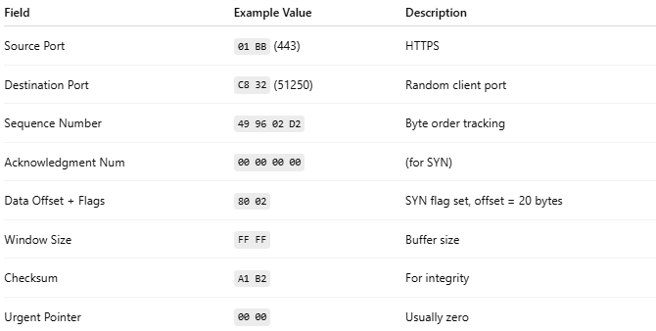

Field | Example Value | Description
Source Port | 01 BB (443) | HTTPS
Destination Port | C8 32 (51250) | Random client port
Sequence Number | 49 96 02 D2 | Byte order tracking
Acknowledgment Num | 00 00 00 00 | (for SYN)
Data Offset + Flags | 80 02 | SYN flag set, offset = 20 bytes
Window Size | FF FF | Buffer size
Checksum | A1 B2 | For integrity
Urgent Pointer | 00 00 | Usually zero
🧱 Total: 20 bytes

💡 Payload (Application Data – HTTP Request)
# Source: Chatgpt (GPT‑5 Mini) at [12/14/2025]
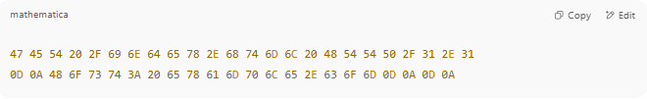
47 45 54 20 2F 69 6E 64 65 78 2E 68 74 6D 6C 20 48 54 54 50 2F 31 2E 31
0D 0A 48 6F 73 74 3A 20 65 78 61 6D 70 6C 65 2E 63 6F 6D 0D 0A 0D 0A

📖 This is:
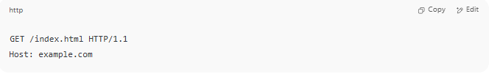
GET /index.html HTTP/1.1
Host: example.com

📦 Full TCP Segment (Hex)
# Source: Chatgpt (GPT‑5 Mini) at [12/14/2025]
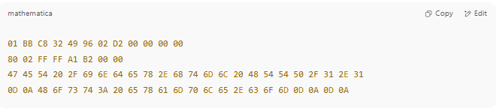
01 BB C8 32 49 96 02 D2 00 00 00 00
80 02 FF FF A1 B2 00 00
47 45 54 20 2F 69 6E 64 65 78 2E 68 74 6D 6C 20 48 54 54 50 2F 31 2E 31
0D 0A 48 6F 73 74 3A 20 65 78 61 6D 70 6C 65 2E 63 6F 6D 0D 0A 0D 0A

🟥 First 20 bytes → TCP Header
🟩 Remaining bytes → Payload

🧠 Recap: TCP Segment Anatomy
# Source: Chatgpt (GPT‑5 Mini) at [12/14/2025]
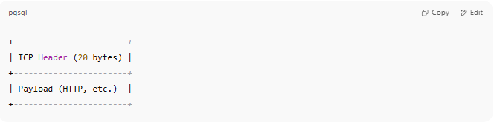
+-----------------------+
| TCP Header (20 bytes) |
+-----------------------+
| Payload (HTTP, etc.) |
+-----------------------+

✅ Summary
# Source: Chatgpt (GPT‑5 Mini) at [12/14/2025]
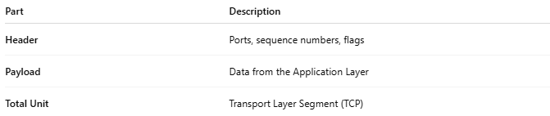
Part | Description
Header | Ports, sequence numbers, flags
Payload | Data from the Application Layer
Total Unit | Transport Layer Segment (TCP)

🆚 Segment vs Datagram
# Source: Chatgpt (GPT‑5 Mini) at [12/14/2025]
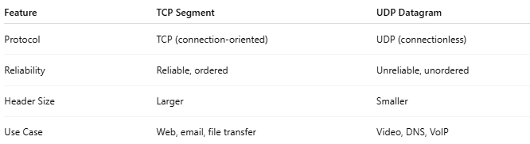
Feature | TCP Segment | UDP Datagram
Protocol | TCP (connection-oriented) | UDP (connectionless)
Reliability | Reliable, ordered | Unreliable, unordered
Header Size | Larger | Smaller
Use Case | Web, email, file transfer | Video, DNS, VoIP

✅ Summary
# Source: Chatgpt (GPT‑5 Mini) at [12/14/2025]
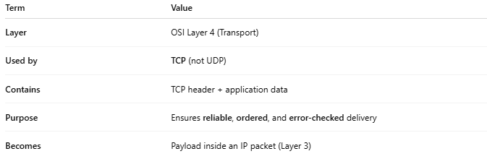
Term | Value
Layer | OSI Layer 4 (Transport)
Used by | TCP (not UDP)
Contains | TCP header + application data
Purpose | Ensures reliable, ordered, and error-checked delivery
Becomes | Payload inside an IP packet (Layer 3)

